A

Report

On

Teacher’s Day 2023

**Department of PHILOSOPHY**

Rabindra Mahavidyalaya, champadanga,hooghly

Session: 2023-24

Theme: **TEACHERS DAY**

Venue: Department of PHILOSOPHY

Rabindra Mahavidyalaya, champadanga,

room no. 71

Date: 5TH September,2023

Organizer: **Department of Philosophy**

Objectives:

* It is a reminder of the role that teachers play in nation-building by guiding and educating the brightest minds of our country.
* To promote good relationship between teachers and students.
* To Respect the teacher's values

Summary

A Teacher’s Day is organized by the students of Philosophy Department on 5th 2023. The program began auspiciously with the lighting of the lamp and garlanding by Professor Soumitra Das (head of the department) and prof. Sanchita Kheto(department prof.) in front of the portrait of Dr. Sarvepalli Radhakrishnan. Principal Sir appeared in the middle of the program and gave his valuable speech. Another departmental professor, non-teaching stuffs, Liberian was present and their presence added to the charm of the event. perform a bunch of cultural programs, such as recitals, dances, songs, speeches etc. are also held. They perform very beautifully. Everyone enjoys it very much. Through various programs they try to show respect and gratitude to teachers.

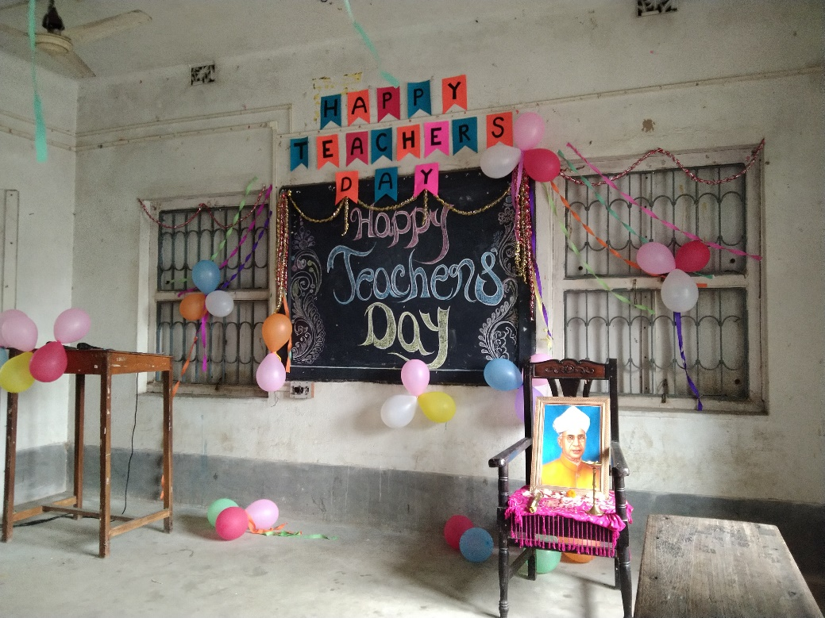

**Decoration of teacher’s day**

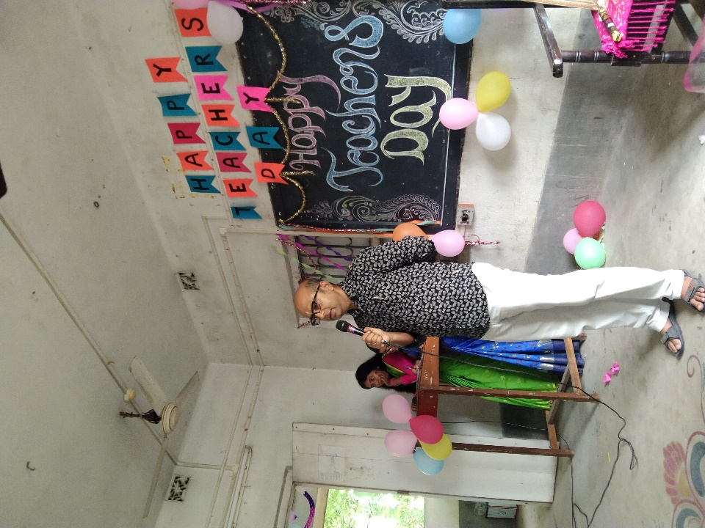

**Speech by principal**

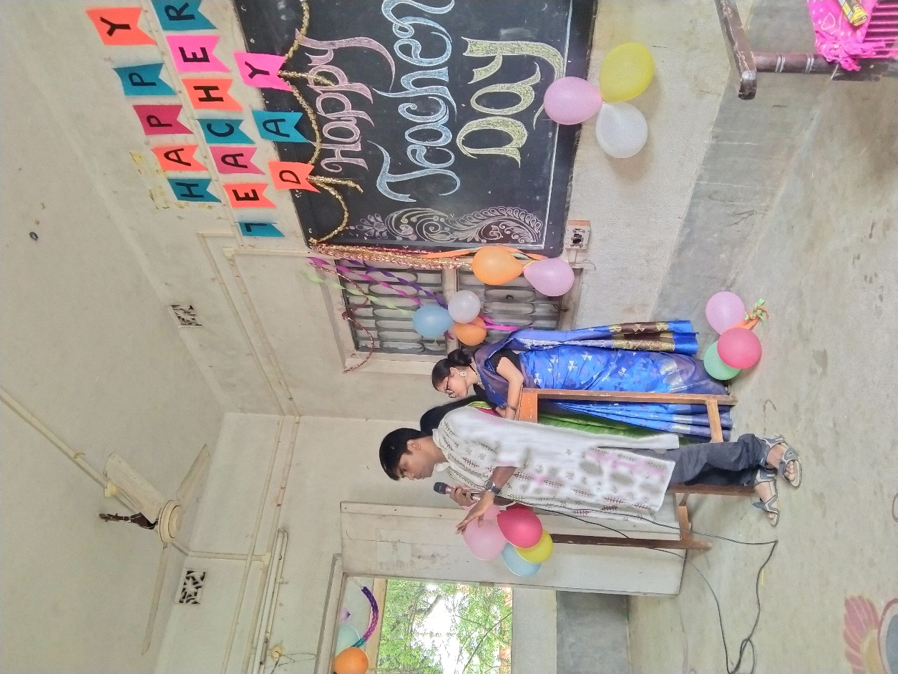

**Inaugural Speech by prof. Soumitra Das, head of the department of philosophy**

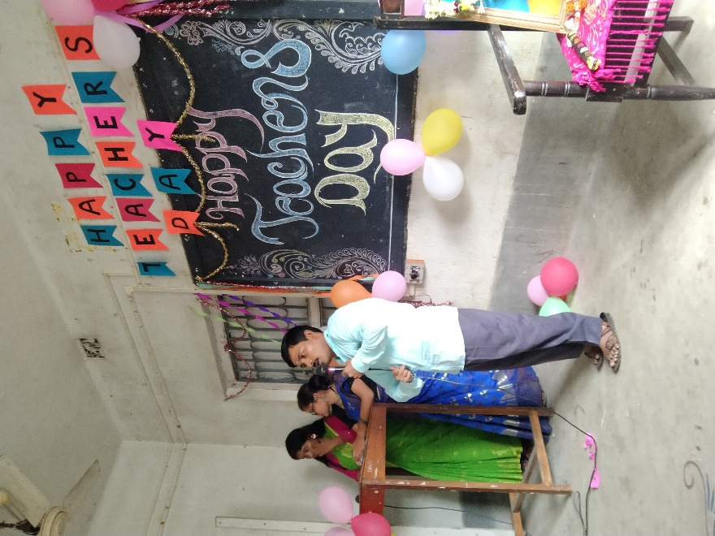

**Speech by Liberian**

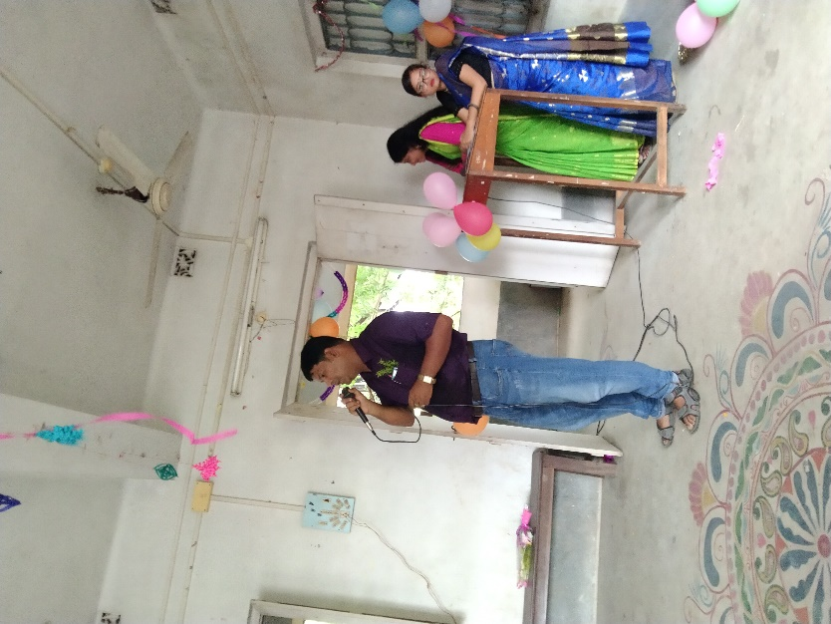

**Sung by Other Departmental prof**.

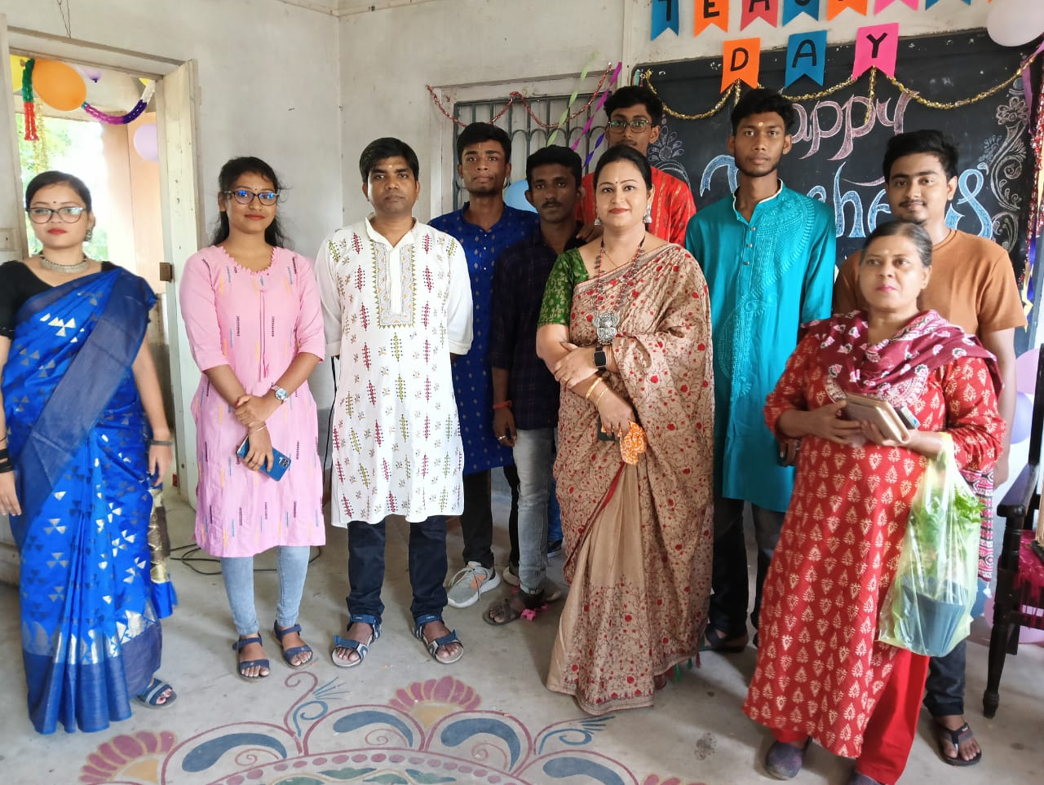

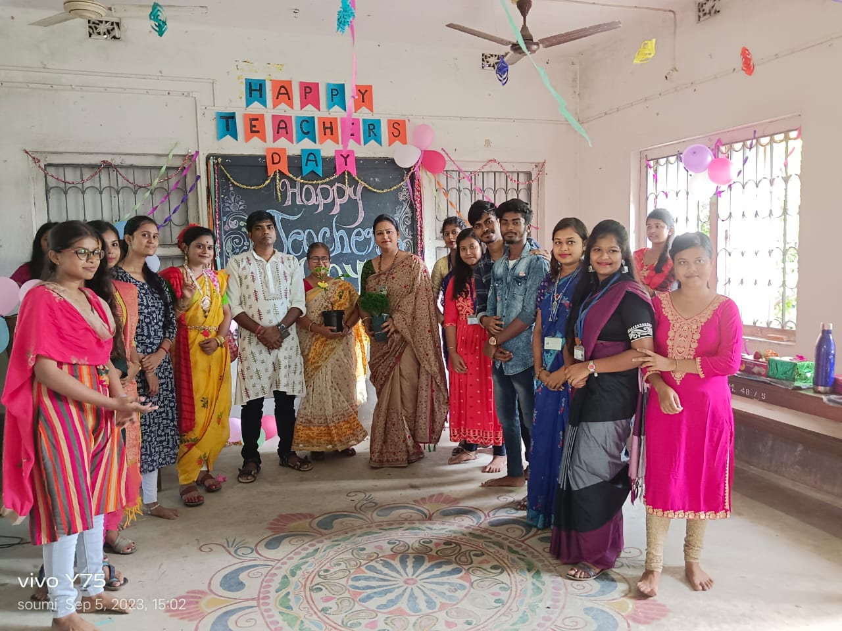

**Our pass out students/alumni**

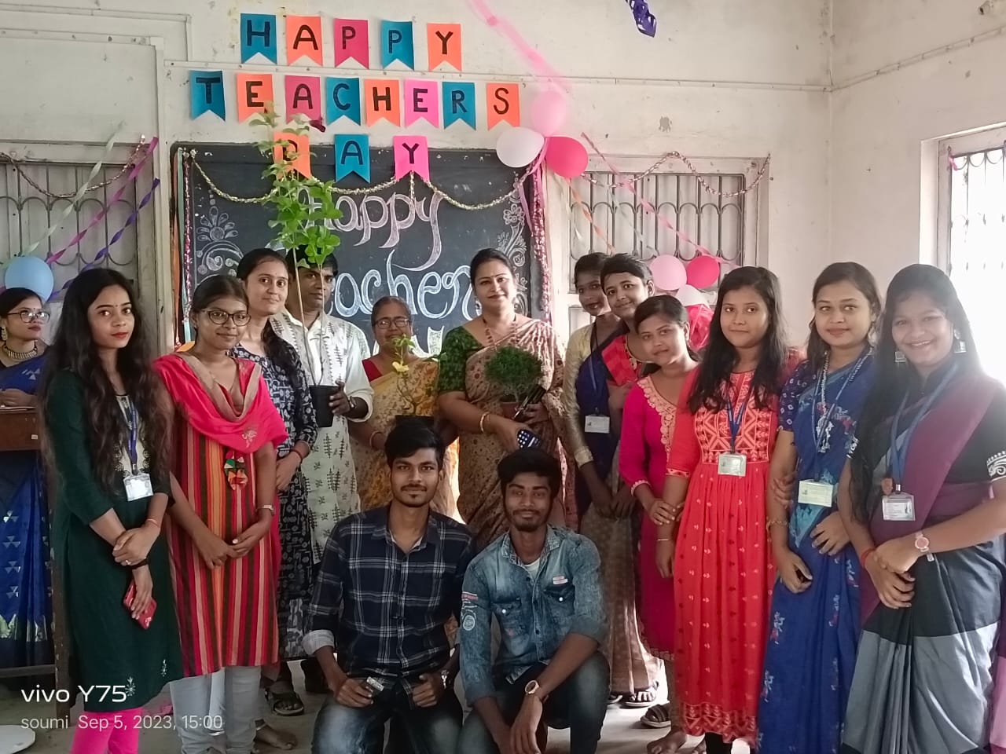

**Our students**

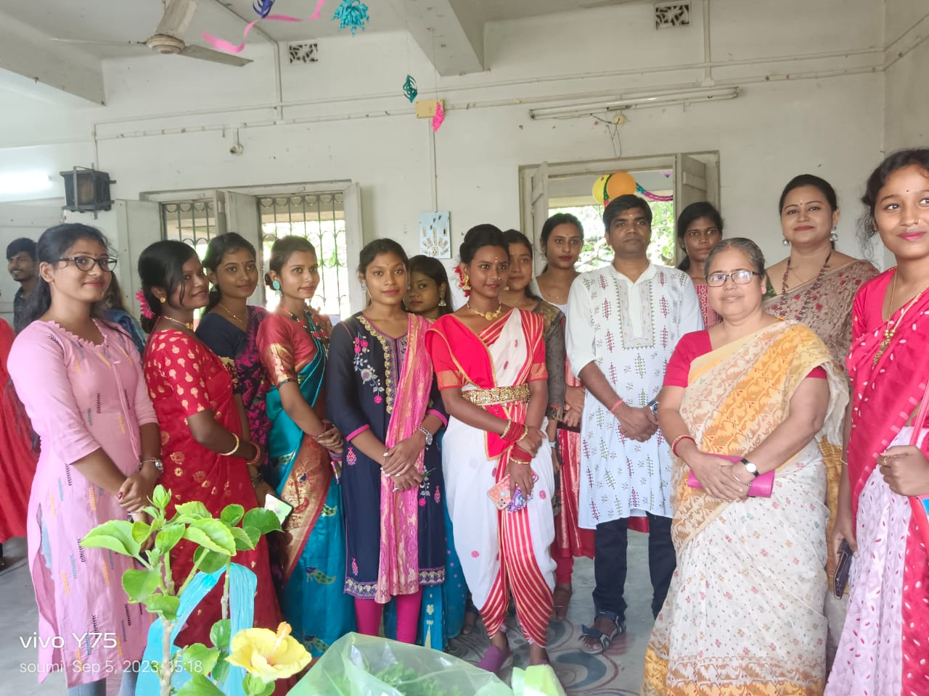

**Our students**

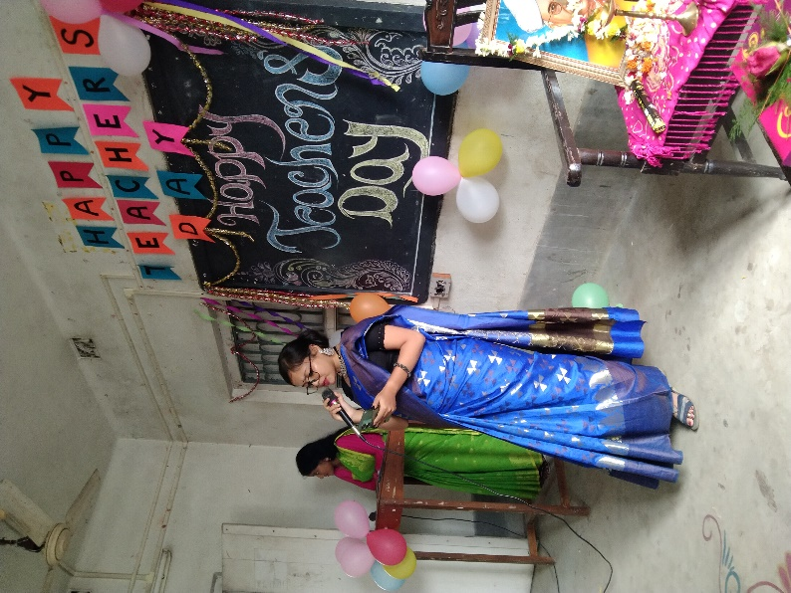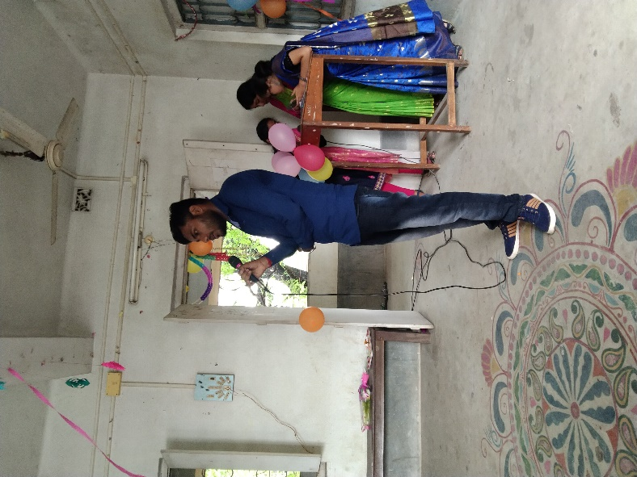

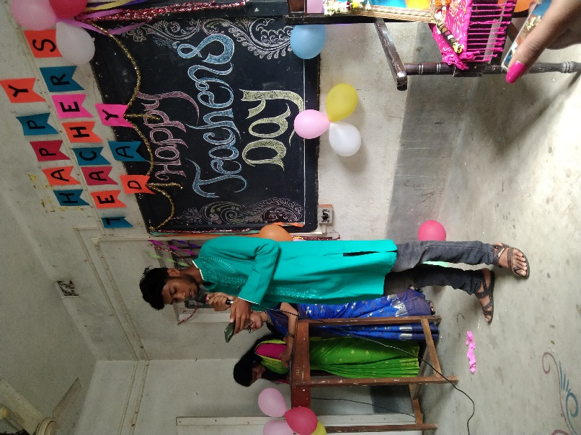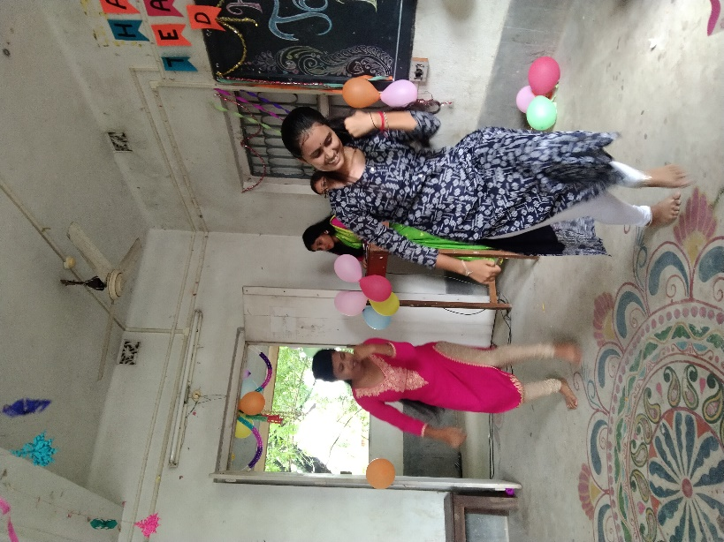

**Different performances by students**

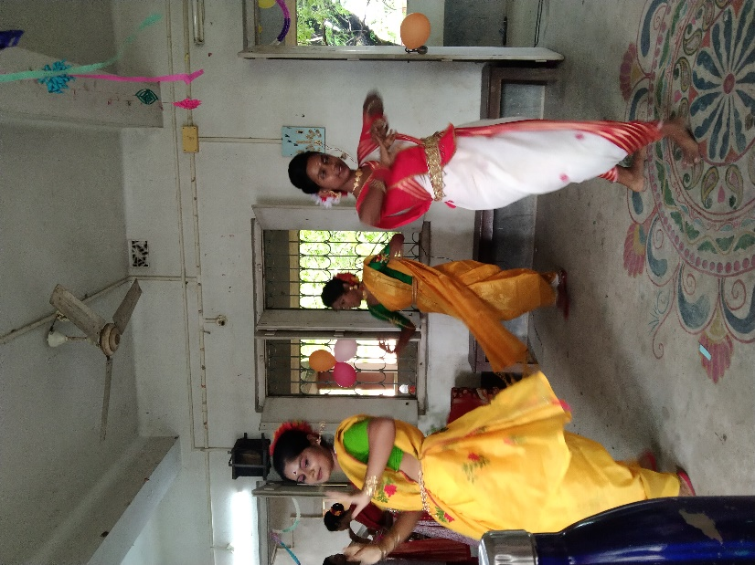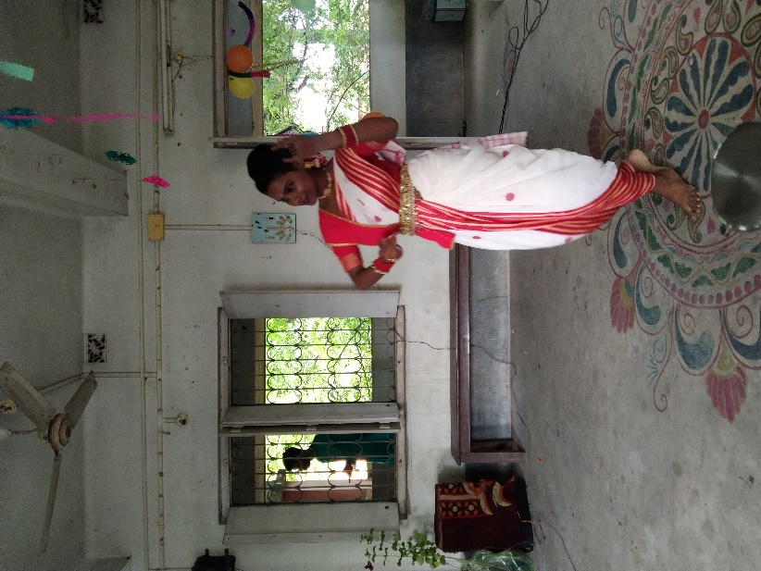

**Different performances by students**

Our perticipent: 80

Male:20

Female:60

Tentative programme schedule

* Inaugural session: 11 :00a.m. to 11.30 a.m.
* Inaugural Speech: 11:30 a.m. to 12.00 noon
* Cultural programme: 12:00 noonto 4:00 p.m.